接口说明

数据结构定义

系统常量定义
// ==================== 系统通用常量 ====================
public static final String SYS_NAME = "户籍管理系统 v1.0";
public static final int SYS_MAX_RETRY_LOGIN = 5; // 登录最大重试次数
public static final int SYS_SESSION_TIMEOUT = 1800; // 会话超时(秒), 30分钟
public static final int SYS_PAGE_SIZE_DEFAULT = 20; // 默认分页条数

// ==================== 字段长度常量 ====================
public static final int LEN_USER_ID = 25; // 用户ID
public static final int LEN_USER_NAME = 50; // 用户姓名
public static final int LEN_PASSWD_MIN = 6; // 密码最小长度
public static final int LEN_PASSWD_MAX = 16; // 密码最大长度
public static final int LEN_ID_CARD = 18; // 身份证号
public static final int LEN_PHONE = 11; // 手机号
public static final int LEN_ADDRESS = 200; // 地址
public static final int LEN_HUKOU_NO = 20; // 户口编号
public static final int LEN_APPLY_NO = 25; // 申请单号
public static final int LEN_CERT_NO = 25; // 证件编号
public static final int LEN_FILE_PATH = 255; // 附件路径
public static final int LEN_REMARK = 500; // 备注/原因
public static final int LEN_IP = 45; // IP地址

// ==================== 业务状态码 ====================
// ----- 申请单状态 -----
public static final int APPLY_STATUS_PENDING = 0; // 待审核
public static final int APPLY_STATUS_APPROVED = 1; // 审核通过
public static final int APPLY_STATUS_REJECTED = 2; // 审核驳回
public static final int APPLY_STATUS_REVOKED = 3; // 已撤销
public static final int APPLY_STATUS_L1_PENDING = 10; // 一级审批中
public static final int APPLY_STATUS_L2_PENDING = 11; // 二级审批中
public static final int APPLY_STATUS_L3_PENDING = 12; // 三级审批中

// ----- 户籍状态 -----
public static final int HUKOU_STATUS_ACTIVE = 0; // 在册(常住)
public static final int HUKOU_STATUS_MOVED_OUT = 1; // 已迁出
public static final int HUKOU_STATUS_ARCHIVED = 2; // 已归档

// ----- 流动人口状态 -----
public static final int FLOAT_STATUS_TEMP = 0; // 暂住中
public static final int FLOAT_STATUS_EXPIRED = 1; // 已到期
public static final int FLOAT_STATUS_CANCELLED = 2; // 已注销

// ----- 重点人员管控等级 -----
public static final int KEY_LEVEL_NORMAL = 0; // 普通关注
public static final int KEY_LEVEL_MEDIUM = 1; // 中等管控
public static final int KEY_LEVEL_HIGH = 2; // 重点管控

// ----- 证件状态 -----
public static final int CERT_STATUS_NORMAL = 0; // 正常
public static final int CERT_STATUS_LOST = 1; // 挂失
public static final int CERT_STATUS_REPLACING = 2; // 补办中
public static final int CERT_STATUS_CANCELLED = 3; // 已作废
public static final int CERT_STATUS_RECEIVED = 4; // 已领取

// ----- 用户登录状态 -----
public static final int USER_STATE_OFFLINE = 0; // 离线
public static final int USER_STATE_ONLINE = 1; // 在线
public static final int USER_STATE_LOCKED = 2; // 已锁定

// ----- 审批结果 -----
public static final int APPROVAL_PASS = 1; // 通过
public static final int APPROVAL_REJECT = 0; // 驳回

// ----- 操作类型(日志) -----
public static final int OP_TYPE_LOGIN = 1; // 登录
public static final int OP_TYPE_LOGOUT = 2; // 登出
public static final int OP_TYPE_INSERT = 3; // 新增
public static final int OP_TYPE_UPDATE = 4; // 修改
public static final int OP_TYPE_APPROVE = 5; // 审批
public static final int OP_TYPE_REVOKE = 6; // 撤销
public static final int OP_TYPE_EXPORT = 7; // 导出
public static final int OP_TYPE_ARCHIVE = 8; // 归档

// ----- Redis Key 前缀 -----
public static final String REDIS_PREFIX_SESSION = "session:"; // 会话缓存
public static final String REDIS_PREFIX_TOKEN = "token:"; // Token
public static final String REDIS_PREFIX_PERM = "perm:"; // 权限菜单
public static final String REDIS_PREFIX_LOCK = "lock:"; // 账号锁定

登录模块
【用户实体 — 系统操作人员基础信息表】
@Data
@Entity
@Table(name = "t_user")
public class stUSER {
@Column(name = "user_id", length = LEN_USER_ID)
private String userID; // 用户ID(主键)
@Column(name = "user_name", length = LEN_USER_NAME)
private String userName; // 用户姓名
@Column(name = "passwd", length = LEN_PASSWD_MAX)
private String passwd; // 加密密码
@Column(name = "phone", length = LEN_PHONE)
private String phone; // 手机号
@Column(name = "id_card", length = LEN_ID_CARD)
private String idCard; // 身份证号
@Column(name = "role")
private Integer role; // 角色: 0-管理员 1-工作人员 2-审核 3-网格
@Column(name = "state")
private Integer state; // 状态: 0-离线 1-在线 2-锁定
@Column(name = "retry_count")
private Integer retryCount; // 连续登录失败次数
@Column(name = "last_login_time", length = 20)
private String lastLoginTime; // 最后登录时间
@Column(name = "last_login_ip", length = LEN_IP)
private String lastLoginIP; // 最后登录IP
@Column(name = "create_time", length = 20)
private String createTime; // 创建时间
// ========== 业务方法 ==========
public stLoginResp login(stLoginReq req); // 用户登录
public void logout(); // 用户登出
public int changePwd(stChgPwdReq req); // 修改密码
}
【登录请求与响应 — 前后端交互数据结构】
@Data
@Entity
@Table(name = "t_login_req")
public class stLOGIN_REQ {
@Column(name = "account", length = LEN_USER_ID)
private String account; // 账号
@Column(name = "passwd", length = LEN_PASSWD_MAX)
private String passwd; // 密码
@Column(name = "remember")
private Integer remember; // 记住登录: 0-否 1-是
@Column(name = "client_ip", length = LEN_IP)
private String clientIP; // 客户端IP
}
@Data
@Entity
@Table(name = "t_login_resp")
public class stLOGIN_RESP {
@Column(name = "ret_code")
private Integer retCode; // 返回码: 0-成功
@Column(name = "ret_msg", length = 200)
private String retMsg; // 返回消息
@Column(name = "token", length = 64)
private String token; // 会话Token
@Column(name = "user_id", length = LEN_USER_ID)
private String userID; // 用户ID
@Column(name = "user_name", length = LEN_USER_NAME)
private String userName; // 用户姓名
@Column(name = "role")
private Integer role; // 角色
@Column(name = "menu_list", columnDefinition = "TEXT")
private String menuList; // 权限菜单JSON
}
【角色枚举与密码修改】
@Data
@Entity
@Table(name = "t_chg_pwd_req")
public class stCHG_PWD_REQ {
@Column(name = "user_id", length = LEN_USER_ID)
private String userID; // 用户ID
@Column(name = "old_passwd", length = LEN_PASSWD_MAX)
private String oldPasswd; // 原密码
@Column(name = "new_passwd", length = LEN_PASSWD_MAX)
private String newPasswd; // 新密码
}
public enum eROLE {
ROLE_ADMIN(0, "系统管理员"),
ROLE_OPERATOR(1, "户籍工作人员"),
ROLE_REVIEWER(2, "审核人员"),
ROLE_GRID(3, "网格员/民警");
}

家庭户口立户模块
【家庭户口实体 — 户口档案主表】
@Data
@Entity
@Table(name = "t_household")
public class stHOUSEHOLD {
@Column(name = "hukou_no", length = LEN_HUKOU_NO)
private String hukouNo; // 户口编号(主键, 地区代码+年份+流水号)
@Column(name = "apply_no", length = LEN_APPLY_NO)
private String applyNo; // 申请单号(唯一)
@Column(name = "householder_name", length = LEN_USER_NAME)
private String householderName; // 户主姓名
@Column(name = "householder_id", length = LEN_ID_CARD)
private String householderID; // 户主身份证号
@Column(name = "address", length = LEN_ADDRESS)
private String address; // 户籍地址
@Column(name = "reason", length = LEN_REMARK)
private String reason; // 立户原因
@Column(name = "apply_date", length = 20)
private String applyDate; // 申请日期
@Column(name = "operator_id", length = LEN_USER_ID)
private String operatorID; // 经办人ID
@Column(name = "status")
private Integer status; // 状态: 0-待审核 1-已立户 2-驳回 3-注销
@Column(name = "reject_reason", length = LEN_REMARK)
private String rejectReason; // 驳回原因
@Column(name = "create_time", length = 20)
private String createTime; // 创建时间
@Column(name = "update_time", length = 20)
private String updateTime; // 最后更新
// ========== 业务方法 ==========
public int apply(); // 提交立户申请
public int audit(stAuditReq req); // 审核户口
}
【家庭成员实体 — 户口下人员明细表】
@Data
@Entity
@Table(name = "t_household_member")
public class stHOUSEHOLD_MEMBER {
@Column(name = "member_id", length = LEN_ID_CARD)
private String memberID; // 成员身份证号(主键)
@Column(name = "hukou_no", length = LEN_HUKOU_NO)
private String hukouNo; // 所属户口编号(外键)
@Column(name = "name", length = LEN_USER_NAME)
private String name; // 姓名
@Column(name = "gender")
private Integer gender; // 性别: 0-男 1-女
@Column(name = "birth_date")
private Date birthDate; // 出生日期
@Column(name = "relation", length = 20)
private String relation; // 与户主关系
@Column(name = "phone", length = LEN_PHONE)
private String phone; // 联系电话
@Column(name = "occupation", length = 50)
private String occupation; // 职业
@Column(name = "create_time", length = 20)
private String createTime; // 创建时间
// ========== 业务方法 ==========
public int addMember(); // 添加成员
public int removeMember(); // 移除成员
}
【审核请求与操作日志】
@Data
@Entity
@Table(name = "t_audit_req")
public class stAUDIT_REQ {
@Column(name = "apply_no", length = LEN_APPLY_NO)
private String applyNo; // 申请单号
@Column(name = "result")
private Integer result; // 审核结果: 1-通过 0-驳回
@Column(name = "opinion", length = LEN_REMARK)
private String opinion; // 审批意见
@Column(name = "auditor_id", length = LEN_USER_ID)
private String auditorID; // 审核人ID
@Column(name = "audit_time", length = 20)
private String auditTime; // 审核时间
}
@Data
@Entity
@Table(name = "t_hukou_log")
public class stHUKOU_LOG {
@Column(name = "log_id", length = 25)
private String logID; // 日志ID
@Column(name = "hukou_no", length = LEN_HUKOU_NO)
private String hukouNo; // 户口编号
@Column(name = "op_type")
private Integer opType; // 操作类型
@Column(name = "operator_id", length = LEN_USER_ID)
private String operatorID; // 操作人ID
@Column(name = "op_content", length = LEN_REMARK)
private String opContent; // 操作内容
@Column(name = "op_time", length = 20)
private String opTime; // 操作时间
}

常住人口管理模块
【常住人口实体 — 系统核心数据主表】
@Data
@Entity
@Table(name = "t_resident")
public class stRESIDENT {
@Column(name = "id_card", length = LEN_ID_CARD)
private String idCard; // 身份证号(主键)
@Column(name = "name", length = LEN_USER_NAME)
private String name; // 姓名
@Column(name = "gender")
private Integer gender; // 性别: 0-男 1-女
@Column(name = "birth_date", length = 20)
private String birthDate; // 出生日期
@Column(name = "nation", length = 20)
private String nation; // 民族
@Column(name = "hukou_no", length = LEN_HUKOU_NO)
private String hukouNo; // 所属户口编号(外键)
@Column(name = "address", length = LEN_ADDRESS)
private String address; // 现住地址
@Column(name = "native_place", length = LEN_ADDRESS)
private String nativePlace; // 籍贯
@Column(name = "marital_status")
private Integer maritalStatus; // 婚姻状况: 0-未婚 1-已婚 2-离异 3-丧偶
@Column(name = "education", length = 20)
private String education; // 文化程度
@Column(name = "occupation", length = 50)
private String occupation; // 职业
@Column(name = "work_unit", length = 100)
private String workUnit; // 工作单位
@Column(name = "phone", length = LEN_PHONE)
private String phone; // 联系电话
@Column(name = "hukou_type")
private Integer hukouType; // 户口类型: 0-农业 1-非农业
@Column(name = "status")
private Integer status; // 状态: 0-在册 1-已迁出 2-已归档
@Column(name = "create_time", length = 20)
private String createTime; // 录入时间
@Column(name = "update_time", length = 20)
private String updateTime; // 最后更新
// ========== 业务方法 ==========
public int add(); // 新增常住人口
public int update(); // 更新常住人口信息
public stPageResp<stResident> queryList(stResidentQuery query);
public int batchOp(stBatchOpReq req); // 批量操作
}
【人口变更记录与查询条件】
@Data
@Entity
@Table(name = "t_resident_change_log")
public class stRESIDENT_CHANGE_LOG {
@Column(name = "change_id", length = 25)
private String changeID; // 变更记录ID
@Column(name = "id_card", length = LEN_ID_CARD)
private String idCard; // 人员身份证号
@Column(name = "field_name", length = 50)
private String fieldName; // 变更字段名
@Column(name = "old_value", length = 200)
private String oldValue; // 变更前值
@Column(name = "new_value", length = 200)
private String newValue; // 变更后值
@Column(name = "change_reason", length = LEN_REMARK)
private String changeReason; // 变更原因
@Column(name = "operator_id", length = LEN_USER_ID)
private String operatorID; // 操作人
@Column(name = "change_time", length = 20)
private String changeTime; // 变更时间
}
@Data
@Entity
@Table(name = "t_resident_query")
public class stRESIDENT_QUERY {
@Column(name = "name", length = LEN_USER_NAME)
private String name; // 姓名(模糊)
@Column(name = "id_card", length = LEN_ID_CARD)
private String idCard; // 身份证号(精确)
@Column(name = "gender")
private Integer gender; // 性别: -1不限
@Column(name = "age_min")
private Integer ageMin;
@Column(name = "age_max")
private Integer ageMax; // 年龄区间
@Column(name = "status")
private Integer status; // 状态: -1不限
@Column(name = "page_num")
private Integer pageNum; // 页码
@Column(name = "page_size")
private Integer pageSize; // 每页条数
}

户口迁入模块
【迁入申请与多级审批记录】
@Data
@Entity
@Table(name = "t_move_in")
public class stMOVE_IN {
@Column(name = "apply_no", length = LEN_APPLY_NO)
private String applyNo; // 申请单号(主键)
@Column(name = "name", length = LEN_USER_NAME)
private String name; // 迁入人员姓名
@Column(name = "id_card", length = LEN_ID_CARD)
private String idCard; // 身份证号
@Column(name = "origin_address", length = LEN_ADDRESS)
private String originAddress; // 原户籍地址
@Column(name = "target_address", length = LEN_ADDRESS)
private String targetAddress; // 落户地址
@Column(name = "reason", length = LEN_REMARK)
private String reason; // 迁入原因
@Column(name = "voucher_no", length = 25)
private String voucherNo; // 凭证编号
@Column(name = "operator_id", length = LEN_USER_ID)
private String operatorID; // 经办人
@Column(name = "status")
private Integer status; // 状态: 10/11/12-多级审批 1-通过 2-驳回 3-撤销
@Column(name = "create_time", length = 20)
private String createTime;
@Column(name = "update_time", length = 20)
private String updateTime;
// ========== 业务方法 ==========
public int apply(); // 提交迁入申请
public int approve(stAuditReq req); // 多级审批
public int revoke(stRevokeReq req); // 撤销申请
public int syncResident(); // 同步至常住人口
}
@Data
@Entity
@Table(name = "t_move_in_approval")
public class stMOVE_IN_APPROVAL {
@Column(name = "approval_id", length = 25)
private String approvalID; // 审批记录ID
@Column(name = "apply_no", length = LEN_APPLY_NO)
private String applyNo; // 申请单号(外键)
@Column(name = "level")
private Integer level; // 审批层级: 1/2/3
@Column(name = "approver_id", length = LEN_USER_ID)
private String approverID; // 审批人
@Column(name = "result")
private Integer result; // 结果: 1-通过 0-驳回
@Column(name = "opinion", length = LEN_REMARK)
private String opinion; // 审批意见
@Column(name = "approval_time", length = 20)
private String approvalTime; // 审批时间
}
@Data
@Entity
@Table(name = "t_move_in_material")
public class stMOVE_IN_MATERIAL {
@Column(name = "material_id", length = 25)
private String materialID; // 材料ID
@Column(name = "apply_no", length = LEN_APPLY_NO)
private String applyNo; // 申请单号(外键)
@Column(name = "material_name", length = 100)
private String materialName; // 材料名称
@Column(name = "file_path", length = LEN_FILE_PATH)
private String filePath; // 附件路径
@Column(name = "verify_status")
private Integer verifyStatus; // 核验状态: 0-待核验 1-通过 2-不通过
}

户口迁出模块
【迁出申请与档案】
@Data
@Entity
@Table(name = "t_move_out")
public class stMOVE_OUT {
@Column(name = "apply_no", length = LEN_APPLY_NO)
private String applyNo; // 申请单号(主键)
@Column(name = "id_card", length = LEN_ID_CARD)
private String idCard; // 迁出人身份证号
@Column(name = "name", length = LEN_USER_NAME)
private String name; // 迁出人姓名
@Column(name = "target_address", length = LEN_ADDRESS)
private String targetAddress; // 目标地址
@Column(name = "reason", length = LEN_REMARK)
private String reason; // 迁出原因
@Column(name = "voucher_no", length = 25)
private String voucherNo; // 凭证编号
@Column(name = "operator_id", length = LEN_USER_ID)
private String operatorID; // 经办人
@Column(name = "status")
private Integer status; // 状态: 0-待审核 1-通过 2-驳回
@Column(name = "reject_reason", length = LEN_REMARK)
private String rejectReason; // 驳回原因
@Column(name = "auditor_id", length = LEN_USER_ID)
private String auditorID; // 审核人
@Column(name = "audit_time", length = 20)
private String auditTime;
// ========== 业务方法 ==========
public int apply(); // 提交迁出申请
public int audit(stAuditReq req); // 审核迁出
}
@Data
@Entity
@Table(name = "t_move_out_archive")
public class stMOVE_OUT_ARCHIVE {
@Column(name = "archive_id", length = 25)
private String archiveID; // 档案ID
@Column(name = "apply_no", length = LEN_APPLY_NO)
private String applyNo; // 申请单号
@Column(name = "id_card", length = LEN_ID_CARD)
private String idCard; // 身份证号
@Column(name = "name", length = LEN_USER_NAME)
private String name; // 姓名
@Column(name = "target_address", length = LEN_ADDRESS)
private String targetAddress; // 目标地址
@Column(name = "move_out_time", length = 20)
private String moveOutTime; // 迁出时间
@Column(name = "operator_id", length = LEN_USER_ID)
private String operatorID; // 经办人
}

流动人口管理模块
【流动人口实体与变更记录】
@Data
@Entity
@Table(name = "t_floating_pop")
public class stFLOATING_POP {
@Column(name = "record_id", length = 25)
private String recordID; // 记录ID(主键)
@Column(name = "name", length = LEN_USER_NAME)
private String name; // 姓名
@Column(name = "id_card", length = LEN_ID_CARD)
private String idCard; // 身份证号(唯一)
@Column(name = "gender")
private Integer gender; // 性别
@Column(name = "temp_address", length = LEN_ADDRESS)
private String tempAddress; // 暂住地址
@Column(name = "area", length = 50)
private String area; // 所属片区
@Column(name = "stay_duration")
private Integer stayDuration; // 停留时长(天)
@Column(name = "work_unit", length = 100)
private String workUnit; // 工作单位
@Column(name = "emergency_contact", length = LEN_USER_NAME)
private String emergencyContact; // 紧急联系人
@Column(name = "emergency_phone", length = LEN_PHONE)
private String emergencyPhone; // 紧急电话
@Column(name = "status")
private Integer status; // 状态: 0-暂住中 1-到期 2-注销
@Column(name = "expected_end_date", length = 20)
private String expectedEndDate; // 预计到期日
@Column(name = "cancel_time", length = 20)
private String cancelTime; // 注销时间
@Column(name = "destination", length = LEN_ADDRESS)
private String destination; // 去向
@Column(name = "operator_id", length = LEN_USER_ID)
private String operatorID; // 经办人
@Column(name = "create_time", length = 20)
private String createTime; // 登记时间
// ========== 业务方法 ==========
public int register(); // 登记流动人口
public int update(); // 更新信息
public int cancel(); // 注销
public stFloatStats queryStats(); // 查询统计
}
@Data
@Entity
@Table(name = "t_float_change_log")
public class stFLOAT_CHANGE_LOG {
@Column(name = "change_id", length = 25)
private String changeID; // 变更记录ID
@Column(name = "record_id", length = 25)
private String recordID; // 记录ID(外键)
@Column(name = "field_name", length = 50)
private String fieldName; // 变更字段
@Column(name = "old_value", length = 200)
private String oldValue; // 变更前值
@Column(name = "new_value", length = 200)
private String newValue; // 变更后值
@Column(name = "operator_id", length = LEN_USER_ID)
private String operatorID; // 变更人
@Column(name = "change_time", length = 20)
private String changeTime; // 变更时间
}

重点人口管理模块
【重点人员档案与跟踪预警 (涉密,需权限保护)】
@Data
@Entity
@Table(name = "t_key_person")
public class stKEY_PERSON {
@Column(name = "archive_id", length = 25)
private String archiveID; // 档案ID(主键)
@Column(name = "name", length = LEN_USER_NAME)
private String name; // 姓名
@Column(name = "gender")
private Integer gender; // 性别
@Column(name = "birth_date")
private Date birthDate; // 出生日期
@Column(name = "id_card", length = LEN_ID_CARD)
private String idCard; // 身份证号(唯一)
@Column(name = "address", length = LEN_ADDRESS)
private String address; // 户籍地址
@Column(name = "current_address", length = LEN_ADDRESS)
private String currentAddress; // 现居地址
@Column(name = "key_type")
private Integer keyType; // 重点关注类型
@Column(name = "key_reason", length = LEN_REMARK)
private String keyReason; // 关注原因
@Column(name = "control_level")
private Integer controlLevel; // 管控等级: 0-普通 1-中等 2-重点
@Column(name = "grid_officer", length = LEN_USER_NAME)
private String gridOfficer; // 网格员
@Column(name = "police_officer", length = LEN_USER_NAME)
private String policeOfficer; // 民警
@Column(name = "status")
private Integer status; // 状态: 0-管控中 1-解除
@Column(name = "create_time", length = 20)
private String createTime;
// ========== 业务方法 ==========
public int createArchive(); // 建立档案
public int addTrack(stKeyPersonTrack track); // 添加动态跟踪
public int changeStatus(stKeyStatusChange change);// 变更管控状态
}
@Data
@Entity
@Table(name = "t_key_person_track")
public class stKEY_PERSON_TRACK {
@Column(name = "track_id", length = 25)
private String trackID; // 跟踪记录ID
@Column(name = "archive_id", length = 25)
private String archiveID; // 档案ID(外键)
@Column(name = "track_type")
private Integer trackType; // 类型: 0-走访 1-近况 2-状态变更
@Column(name = "content", length = LEN_REMARK)
private String content; // 跟踪内容
@Column(name = "operator_id", length = LEN_USER_ID)
private String operatorID; // 记录人
@Column(name = "track_time", length = 20)
private String trackTime; // 跟踪时间
}
@Data
@Entity
@Table(name = "t_key_status_change")
public class stKEY_STATUS_CHANGE {
@Column(name = "change_id", length = 25)
private String changeID; // 变更记录ID
@Column(name = "archive_id", length = 25)
private String archiveID; // 档案ID(外键)
@Column(name = "old_level")
private Integer oldLevel; // 原管控等级
@Column(name = "new_level")
private Integer newLevel; // 新管控等级
@Column(name = "change_reason", length = LEN_REMARK)
private String changeReason; // 变更原因
@Column(name = "operator_id", length = LEN_USER_ID)
private String operatorID; // 操作人
@Column(name = "change_time", length = 20)
private String changeTime;
}
@Data
@Entity
@Table(name = "t_key_alert")
public class stKEY_ALERT {
@Column(name = "alert_id", length = 25)
private String alertID; // 预警ID
@Column(name = "archive_id", length = 25)
private String archiveID; // 档案ID(外键)
@Column(name = "alert_type")
private Integer alertType; // 预警类型: 0-超期回访 1-状态异常
@Column(name = "alert_content", length = LEN_REMARK)
private String alertContent; // 预警内容
@Column(name = "is_resolved")
private Integer isResolved; // 已处理: 0-否 1-是
@Column(name = "create_time", length = 20)
private String createTime;
}

证件管理模块
【证件实体、挂失补办与作废记录】
@Data
@Entity
@Table(name = "t_certificate")
public class stCERTIFICATE {
@Column(name = "cert_no", length = LEN_CERT_NO)
private String certNo; // 证件编号(主键,唯一)
@Column(name = "holder_id_card", length = LEN_ID_CARD)
private String holderIdCard; // 持证人身份证号
@Column(name = "holder_name", length = LEN_USER_NAME)
private String holderName; // 持证人姓名
@Column(name = "cert_type")
private Integer certType; // 证件类型: 0-身份证 1-户口本 2-证明
@Column(name = "status")
private Integer status; // 状态: 0-正常 1-挂失 2-补办 3-作废 4-领取
@Column(name = "issue_date", length = 20)
private String issueDate; // 发证日期
@Column(name = "expire_date", length = 20)
private String expireDate; // 有效截止日
@Column(name = "is_received")
private Integer isReceived; // 已领取: 0-否 1-是
@Column(name = "operator_id", length = LEN_USER_ID)
private String operatorID; // 办理人
@Column(name = "create_time", length = 20)
private String createTime;
// ========== 业务方法 ==========
public int register(); // 登记新证件
public int reportLoss(stCertLoss loss); // 挂失
public int cancel(stCertCancel cancel); // 作废
}
@Data
@Entity
@Table(name = "t_cert_loss")
public class stCERT_LOSS {
@Column(name = "loss_id", length = 25)
private String lossID; // 挂失记录ID
@Column(name = "old_cert_no", length = LEN_CERT_NO)
private String oldCertNo; // 原证件编号
@Column(name = "new_cert_no", length = LEN_CERT_NO)
private String newCertNo; // 新证件编号
@Column(name = "loss_reason", length = LEN_REMARK)
private String lossReason; // 挂失原因
@Column(name = "progress")
private Integer progress; // 补办进度: 0-挂失 1-补办中 2-办结
@Column(name = "operator_id", length = LEN_USER_ID)
private String operatorID; // 经办人
@Column(name = "loss_time", length = 20)
private String lossTime;
}
@Data
@Entity
@Table(name = "t_cert_cancel")
public class stCERT_CANCEL {
@Column(name = "cancel_id", length = 25)
private String cancelID; // 作废记录ID
@Column(name = "cert_no", length = LEN_CERT_NO)
private String certNo; // 证件编号
@Column(name = "reason", length = LEN_REMARK)
private String reason; // 作废原因
@Column(name = "operator_id", length = LEN_USER_ID)
private String operatorID; // 操作人
@Column(name = "cancel_time", length = 20)
private String cancelTime;
}

系统通用功能模块
【操作日志、消息提醒与数据备份】
@Data
@Entity
@Table(name = "t_op_log")
public class stOP_LOG {
@Column(name = "log_id", length = 25)
private String logID; // 日志ID
@Column(name = "operator_id", length = LEN_USER_ID)
private String operatorID; // 操作账号
@Column(name = "op_type")
private Integer opType; // 操作类型
@Column(name = "module_name", length = 50)
private String moduleName; // 操作模块
@Column(name = "op_content", length = LEN_REMARK)
private String opContent; // 操作内容
@Column(name = "op_time", length = 20)
private String opTime; // 操作时间
@Column(name = "op_ip", length = LEN_IP)
private String opIP; // 操作IP
// ========== 业务方法 ==========
public static void record(stOpLog log); // 记录操作日志
}
@Data
@Entity
@Table(name = "t_notification")
public class stNOTIFICATION {
@Column(name = "notif_id", length = 25)
private String notifID; // 消息ID
@Column(name = "target_user_id", length = LEN_USER_ID)
private String targetUserID; // 目标用户
@Column(name = "notif_type")
private Integer notifType; // 类型: 0-待审 1-到期 2-预警 3-驳回
@Column(name = "title", length = 100)
private String title; // 标题
@Column(name = "content", length = LEN_REMARK)
private String content; // 内容
@Column(name = "is_read")
private Integer isRead; // 已读: 0-未读 1-已读
@Column(name = "create_time", length = 20)
private String createTime;
// ========== 业务方法 ==========
public int send(); // 推送消息
public int markAsRead(); // 标记已读
}
@Data
@Entity
@Table(name = "t_backup_log")
public class stBACKUP_LOG {
@Column(name = "backup_id", length = 25)
private String backupID; // 备份ID
@Column(name = "backup_type")
private Integer backupType; // 类型: 0-手动 1-自动
@Column(name = "file_name", length = 255)
private String fileName; // 文件名
@Column(name = "file_size")
private Integer fileSize; // 文件大小
@Column(name = "operator_id", length = LEN_USER_ID)
private String operatorID; // 操作人
@Column(name = "backup_time", length = 20)
private String backupTime;
}

内部支撑模块
【权限控制 / 数据校验 / 会话缓存 / 通信 / 定时 / 数据库】
// ==================== 权限控制模块 ====================
@Data
@Entity
@Table(name = "t_role_perm")
public class stROLE_PERM {
@Column(name = "role")
private Integer role; // 角色
@Column(name = "menu_list", columnDefinition = "TEXT")
private String menuList; // 菜单权限JSON
@Column(name = "func_list", columnDefinition = "TEXT")
private String funcList; // 功能权限JSON
}
@Data
@Entity
@Table(name = "t_perm_check_req")
public class stPERM_CHECK_REQ {
@Column(name = "user_id", length = LEN_USER_ID)
private String userID; // 用户ID
@Column(name = "role")
private Integer role; // 角色
@Column(name = "module_name", length = 50)
private String moduleName; // 模块
@Column(name = "func_name", length = 50)
private String funcName; // 功能
}
@Data
@Entity
@Table(name = "t_perm_check_result")
public class stPERM_CHECK_RESULT {
@Column(name = "has_access")
private Integer hasAccess; // 有权限: 0-否 1-是
@Column(name = "deny_reason", length = 100)
private String denyReason; // 拒绝原因
}
// ==================== 数据校验模块 ====================
@Data
@Entity
@Table(name = "t_validate_result")
public class stVALIDATE_RESULT {
@Column(name = "is_valid")
private Integer isValid; // 合法: 0-否 1-是
@Column(name = "err_code", length = 10)
private String errCode; // 错误码
@Column(name = "err_msg", length = 200)
private String errMsg; // 错误描述
@Column(name = "err_field", length = 50)
private String errField; // 出错字段
}
// ==================== 会话缓存模块 (Redis) ====================
@Data
@Entity
@Table(name = "t_session")
public class stSESSION {
@Column(name = "token", length = 64)
private String token; // Token(Key)
@Column(name = "user_id", length = LEN_USER_ID)
private String userID; // 用户ID
@Column(name = "user_name", length = LEN_USER_NAME)
private String userName; // 用户姓名
@Column(name = "role")
private Integer role; // 角色
@Column(name = "permission", columnDefinition = "TEXT")
private String permission; // 权限JSON
@Column(name = "login_time", length = 20)
private String loginTime; // 登录时间
@Column(name = "last_active_time", length = 20)
private String lastActiveTime; // 最后活跃
@Column(name = "expire_seconds")
private Integer expireSeconds; // 过期秒数
// ========== 业务方法 ==========
public boolean isValid(); // 验证会话
public void refresh(); // 刷新过期时间
}
// ==================== 通信传输模块 ====================
@Data
@Entity
@Table(name = "t_req_msg")
public class stREQ_MSG {
@Column(name = "token", length = 64)
private String token; // 会话Token
@Column(name = "module", length = 50)
private String module; // 目标模块
@Column(name = "action", length = 50)
private String action; // 操作动作
@Column(name = "body", columnDefinition = "TEXT")
private String body; // 请求体JSON
@Column(name = "body_len")
private Integer bodyLen; // 请求体长度
}
@Data
@Entity
@Table(name = "t_resp_msg")
public class stRESP_MSG {
@Column(name = "ret_code")
private Integer retCode; // 返回码
@Column(name = "ret_msg", length = 200)
private String retMsg; // 返回消息
@Column(name = "data", columnDefinition = "TEXT")
private String data; // 响应数据JSON
}
// ==================== 定时任务模块 ====================
@Data
@Entity
@Table(name = "t_scheduled_task")
public class stSCHEDULED_TASK {
@Column(name = "task_id", length = 25)
private String taskID; // 任务ID
@Column(name = "task_name", length = 50)
private String taskName; // 任务名称
@Column(name = "task_type")
private Integer taskType; // 类型: 0-暂住到期 1-证件到期 2-回访预警 3-统计
@Column(name = "cron_expr", length = 20)
private String cronExpr; // Cron表达式
@Column(name = "is_active")
private Integer isActive; // 启用: 0-否 1-是
// ========== 业务方法 ==========
public int enable(); // 启用
public int disable(); // 停用
public int execute(); // 手动执行
}
@Data
@Entity
@Table(name = "t_task_exec_log")
public class stTASK_EXEC_LOG {
@Column(name = "exec_id", length = 25)
private String execID; // 执行ID
@Column(name = "task_id", length = 25)
private String taskID; // 任务ID
@Column(name = "exec_status")
private Integer execStatus; // 状态: 0-成功 1-失败
@Column(name = "exec_result", length = LEN_REMARK)
private String execResult; // 执行结果
@Column(name = "start_time", length = 20)
private String startTime;
@Column(name = "end_time", length = 20)
private String endTime;
}
// ==================== 数据库交互模块 ====================
@Data
@Entity
@Table(name = "t_db_config")
public class stDB_CONFIG {
@Column(name = "host", length = 64)
private String host; // 主机
@Column(name = "port")
private Integer port; // 端口
@Column(name = "db_name", length = 50)
private String dbName; // 数据库名
@Column(name = "user", length = 50)
private String user; // 用户名
@Column(name = "passwd", length = LEN_PASSWD_MAX)
private String passwd; // 密码
@Column(name = "pool_size")
private Integer poolSize; // 连接池大小
@Column(name = "timeout")
private Integer timeout; // 超时(ms)
}
@Data
@Entity
@Table(name = "t_db_result")
public class stDB_RESULT {
@Column(name = "affected_rows")
private Integer affectedRows; // 影响行数
@Column(name = "last_insert_id")
private Integer lastInsertId; // 最后插入ID
@Column(name = "err_code")
private Integer errCode; // 错误码
@Column(name = "err_msg", length = 200)
private String errMsg; // 错误消息
}

类图
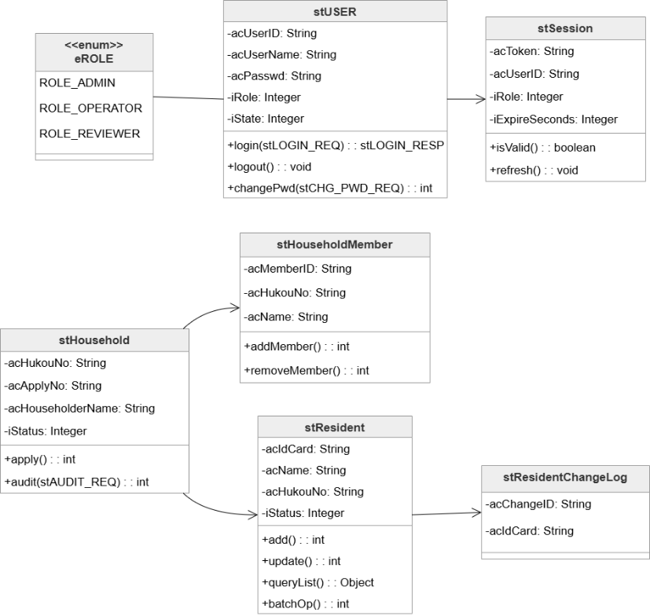
图1 核心实体类图
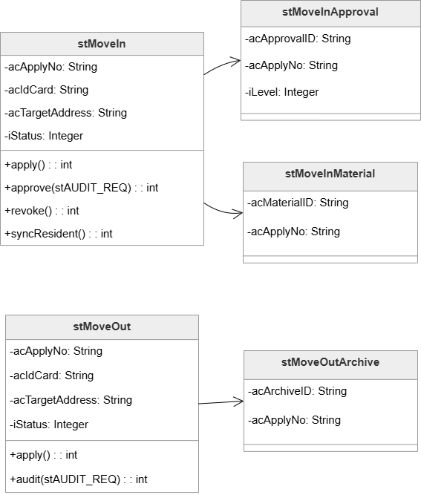
图2 业务办理类图

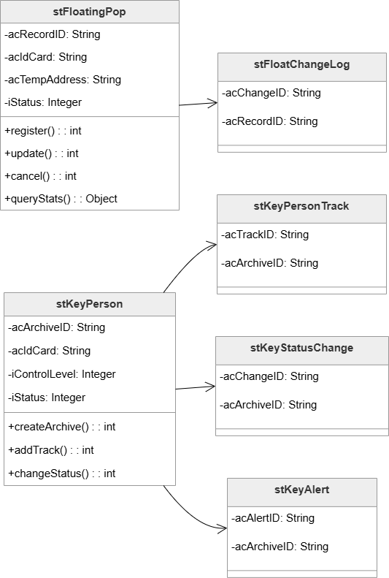
图3 流动人口&重点人口管理类图
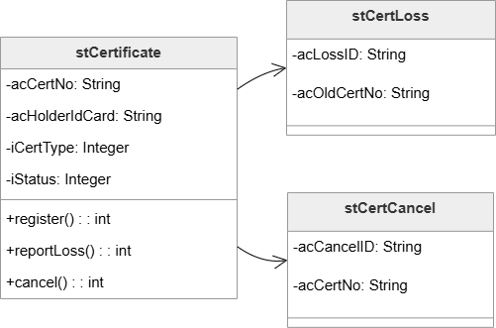
图4 证件管理类图
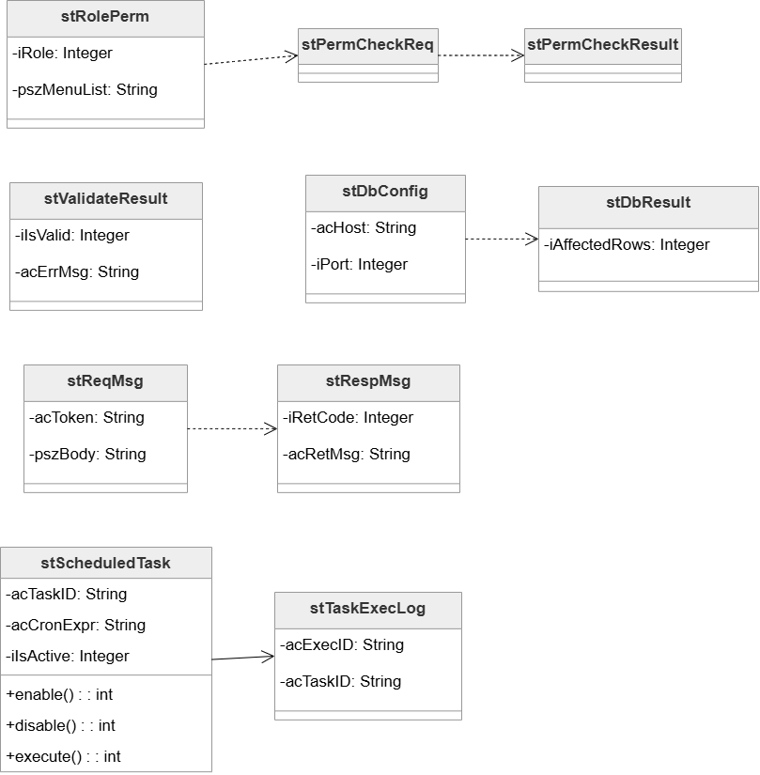
图5 内部支撑类图

方法/函数的定义

模块间接口函数

send
方法名 | send
功能概要 | 发送
记述形式 | int send(int socket_fd, char pcBuffer)
参数
类型 | 变量名 |  | I/O | 说明
Integer | socket_fd |  | I | 套接字标示符
Long | pcBuffer |  | I | 缓冲区
返回值 | 类型 | int | 说明
 | 值 | 0 | 发送成功
 |  | 1 | 发送失败

receive
函数名 | receive
功能概要 | 接收
记述形式 | int receive(int socket_fd, char* pcBuffer)
参数
类型 | 变量名 |  | I/O | 说明
int | socket_fd |  | I | 套接字标示符
char* | pcBuffer |  | I | 缓冲区
返回值 | 类型 | int | 说明
 | 值 | 0 | 接收成功
 |  | 1 | 接收失败

模块内接口函数

checkLoginInput
函数名 | checkLoginInput
功能概要 | 检查用户输入的账号密码时候是否合法（客户端，模块内）
记述形式 | int checkLoginInput(char *pcUserID, char* pcPasswd)
参数
类型 | 变量名 |  | I/O | 说明
char* | pcUserID |  | I | 账户
char* | pcPasswd |  | I | 密码
返回值 | 类型 | int | 说明
 | 值 | 0 | 输入合法
 |  | 1 | 账户含有非法字符
 |  | 2 | 密码不合法(长度或非法字符)
以下表格内容格式，请参考课件“软件工程课程设计报告-第XX组.docx”模版格式

